**Acropolis Institute Of Technology And Research**



**Subject – Database Management System (DBMS)**

**(CY-405)**

**Name – Ashish Prajapat**

**Enrollment No. - 0827CY221016**

**Branch - CS(Cyber Security)**

**Semester- 4th (2nd year)**

**Submitted To –Mrs. Nidhi Nigam Ma’am**

**Index**

|  |  |  |  |  |
| --- | --- | --- | --- | --- |
| **Sr.No.** | **Experiment** | **Date of Exp.** | **Date of sub.** | **Grade** |
| 1. | To study DBMS and RDBMS, its characteristic comparisons and study of popular DB software. | 11/03/24 | 18/03/24 |  |
| 2. | To study of ER diagram. |  |  |  |
| 3. | To study of SQL and its types. |  |  |  |
|  |  |  |  |  |
|  |  |  |  |  |
|  |  |  |  |  |
|  |  |  |  |  |
|  |  |  |  |  |
|  |  |  |  |  |
|  |  |  |  |  |
|  |  |  |  |  |
|  |  |  |  |  |

**Experiment-1**

**AIM:-**

To study DBMS and RDBMS, its characteristic comparisons and study of popular DB software.

**Study Of Database Management System(DBMS):-**

DBMS is a software that permits the creation, employer, and control of databases. It provides a fixed set of equipment and capabilities to save, retrieve, alter, and delete information in an established way. DBMS gives a convenient manner to address massive volumes of information by way of presenting an interface between customers or programs and the underlying database.

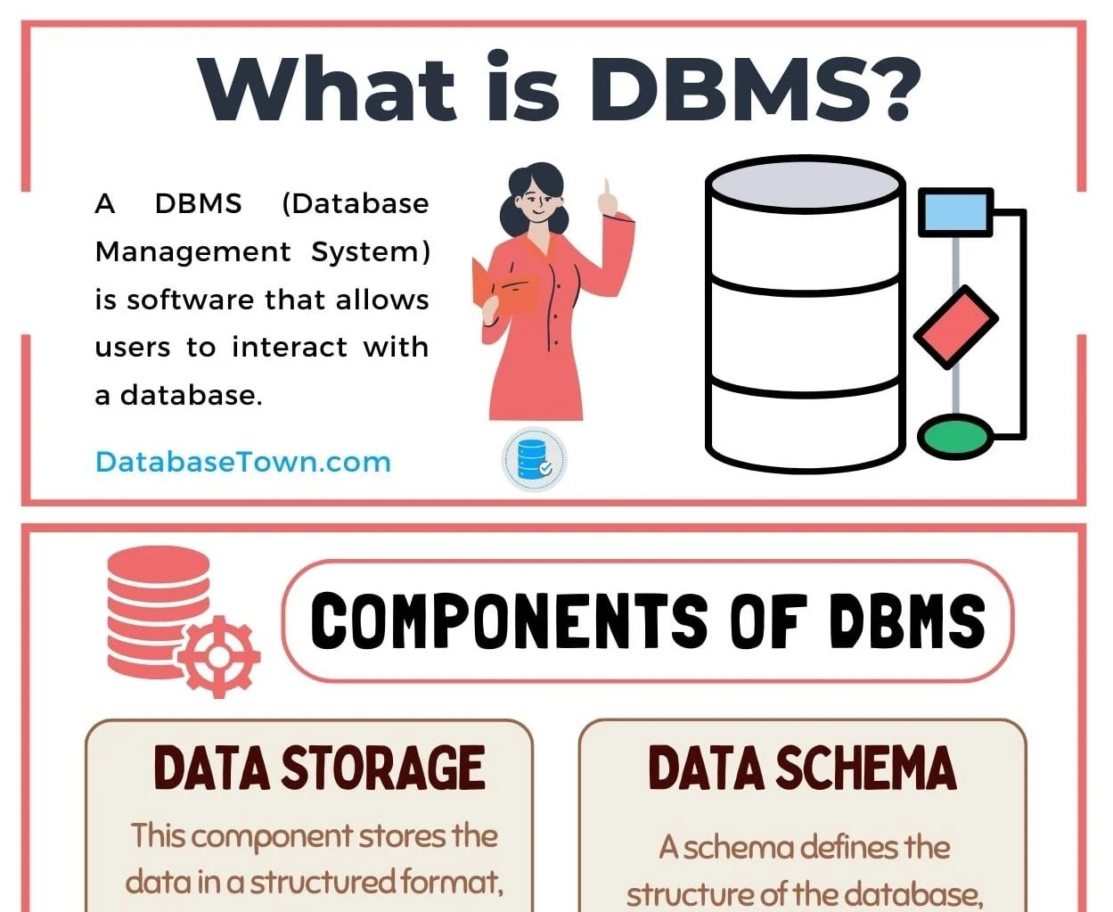

**Functions Of DBMS:-**

1. Data Organization
2. Data Independency
3. Data Security
4. Data Integrity

**Applications Of DBMS:-**

1. Business Applications
2. Banking and Finance
3. Healthcare Systems
4. E-commerce
5. Airlines and Travel Industries

**Study Of Relational Database Management System(RDBMS):-**

A RDBMS is a form of DBMS that stores and manages facts in a tabular format, prepared as tables with rows and columns. It is based on the relational version proposed via Edgar F. Codd within the 1970s. RDBMS is widely used because of its simplicity, scalability, and efficiency in dealing with complicated relationships between entities.

**Functions Of RDBMS:-**

1. Data Structure
2. ACID Compliance
3. Query Language
4. Scalability

**Applications Of RDBMS:-**

1. Enterprise Applications
2. Web Applications
3. Scientific Research
4. Government Systems

**Characteristic Comparison between DBMS and RDBMS:-**

|  |  |  |
| --- | --- | --- |
| **No.** | **DBMS** | **RDBMS** |
| 1. | DBMS applications store **data as file**. | RDBMS applications store **data in a tabular form**. |
| 2. | There is **no relation between the tables.** | Data values are stored in the form of tables, so a **relationship** between these data values will be stored in the form of a table as well. |
| 3. | **Does not support distributed database.** | **Supports distributed database.** |
| 4. | Deals with **small amount of data.** | Deals **with large amount of data.** |
| 5. | For **single user.** | For **multiple users.** |
| 6. | Less secure. | More Secure. |
| 7. | Data Redundancy is common. | No. Data Redundancy due to Keys and indexes. |
| 8. | Less than 7 Codd rules are satisfied. | More than 7 or all 12 Codd rules are satisfied. |
| 9. | Data fetching is slower. | Data fetching is faster. |
| 10. | Low software and hardware necessities. | Higher software and hardware necessities. |
| 11. | Ex:- Xml | Ex:- MySQL, Microsoft Access |

**Study Of Database Software:-**

**Characteristic Comparison between SQL and NoSQL:-**

|  |  |  |
| --- | --- | --- |
| **No.** | **SQL** | **NoSQl** |
| 1. | RDBMS | Non-relational Or Distributed database system. |
| 2. | Fixed or static or pre-defined schema. | Dynamic Schema. |
| 3. | Not for hierarchical data storage. | For hierarchical data storage. |
| 4. | Follows ACID property. | Does not follows ACID property. |
| 5. | Ex:- MySQL, Oracle | Ex:-MongoDB,HBase |